**Cognitive Load Detection during Mental Tasks using Time and Frequency Domain Features of EEG**

***A Thesis Submitted***

***In Partial Fulfillment of the Requirements***

***for the Degree of***

**Bachelors of Technology**

***In***

**Computer Science And Engineering**

***By***

**Md Shafiullah Quraishi**

(Roll No. 20CS8085)

*Under the Supervision*

*of*

**Prof. Tandra Pal**



**DEPARTMENT OF COMPUTER SCIENCE AND ENGINEERING**

**National Institute of Technology Durgapur**

**West Bengal – 713209**

**India**

**April, 2024**



**DEPARTMENT OF COMPUTER SCIENCE AND ENGINEERING  
NATIONAL INSTITUTE OF TECHNOLOGY  
DURGAPUR, INDIA**

**Declaration**

I hereby declare that the work, which is presented in dissertation entitled " **Cognitive Load Detection Through Time Domain And Frequency domain features "** is the partial fulfillment of the requirements for the award of the degree of Bachelor of Technology in the field of Computer Science & Engineering with specialization in Computer Science & Engineering. It is an authentic documentation of my own original work carried out from July 2023 to May 2024 under the noble guidance of Prof. Tandra Pal, Department of Computer Science & Engineering, NIT Durgapur. None of matter contained therein has been copied or extracted from anywhere else. The work has been carried out entirely at National Institute of Technology Durgapur, West Bengal. The matter embodied in this dissertation, in part or whole, has not been presented or submitted by me for any purpose in any other institute or organization for the award of any other degree. I further declare that the facts mentioned above are true to the best of my knowledge. In case of any unlikely discrepancy that may possibly occur, I will be the one to take responsibility.

Durgapur Md Shafiullah Quraishi

May, 2024 Roll No: 20CS8085



**DEPARTMENT OF COMPUTER SCIENCE AND ENGINEERING  
NATIONAL INSTITUTE OF TECHNOLOGY  
DURGAPUR, INDIA**

**CERTIFICATE**

It is certified that the work contained in the thesis entitled " **Cognitive Load Detection Through Time Domain And Frequency domain features "** by has been carried out by **“Md Shafiullah Quraishi (Roll No. 20CS8085)”** under the guidance of “**Prof. Tandra Pal”** the data reported herein is original and that the this work has not been submitted elsewhere for any other Degree or Diploma.

---------------------------------------

**Md Shafiullah Quraishi**

(Candidate)

Place………………………….:

Date…………………………..:

This is to certify that the above declaration is true.

--------------------------------------

**Prof. Tandra Pal**

Place: ……………………………..

Date……………………………….:



**DEPARTMENT OF COMPUTER SCIENCE AND ENGINEERING  
NATIONAL INSTITUTE OF TECHNOLOGY  
DURGAPUR, INDIA**

**Certificate Of Recommendation**

This is to certify that the thesis entitled “Cognitive Load Detection Through Time Domain And Frequency domain features”, submitted by “ Md Shafiullah Quraishi (20CS8085)” of Department of Computer Science & Engineering, National Institute of Technology, Durgapur, in partial fulfilment of the requirements for the award of the degree in Bachelor of Technology in Computer Science & Engineering is a bonafide record of work carried out by him/her under my/our guidance during the academic year 2023 – 2024.

**Professor and Head**

Department of Computer Science and Engineering

National Institute of Technology

Durgapur

|  |
| --- |
| **Prof. Tandra Pal**  Professor  Department of Computer Science and Engineering  National Institute of Technology  Durgapur |



**DEPARTMENT OF COMPUTER SCIENCE AND ENGINEERING  
NATIONAL INSTITUTE OF TECHNOLOGY  
DURGAPUR, INDIA**

**Certificate Of Approval**

This is to certify that we have examined the thesis entitled “Cognitive Load Detection Through Time Domain And Frequency domain features”, submitted by “Md Shafiullah Quraishi (20CS8085)” and hereby accord our approval of it as a study carried out and presented in a manner required for its acceptance in partial fulfillment of the requirements for the award of the degree in Bachelor of Technology in Computer Science Engineering for which it has been submitted. It is to be understood that by this approval the undersigned do not necessarily endorse or approve any statement made, opinion expressed or conclusion drawn therein but approve the thesis only for the purpose for which it is submitted.

**Examiners:**

|  |
| --- |
| **Name Signature** |
|  |
|  |
|  |

**Acknowledgement**

I am deeply grateful to my esteemed research supervisor, Prof. Tandra Pal, for her unwavering guidance, patience, and encouragement throughout this project. Prof. Pal's invaluable support and insightful advice have been pivotal in shaping the trajectory of this endeavor. Her dedication to my academic growth has been truly inspiring, and I owe much of the success of this project to her mentorship.

I extend my sincere appreciation to Prof. Tanmoy De, the Head of the CSE Department, for fostering an environment that nurtures learning and innovation. Additionally, I am thankful to all the faculty members of our department for their encouragement and assistance along the way.

Special recognition is owed to PhD scholar, Subashis Karmakar, whose collaborative spirit and unwavering support have enriched this project immensely. His insightful feedback and shared enthusiasm have been invaluable contributions, and I am grateful for his partnership.

I wish to express my gratitude to my dear friend Kondeti Nikhil and all those who offered their unwavering support and companionship throughout this journey, both academically and personally.

Lastly, my deepest appreciation goes to my family and friends for their steadfast love and support. Their encouragement has been a constant source of strength, and I am profoundly thankful for their presence in my life. Together, each of these individuals has played an integral role in the realization of this project, and for that, I am truly grateful.

**Date: 24/04/2024 Md Shafiullah Quraishi**

Roll No – 20CS8085

Department of Computer Science And Engineering

National Institute of Technology Durgapur

West Bengal – 713209, India

**Table of Contents**

|  |  |
| --- | --- |
| Declaration …………………………………………………………………. | ii. |
| Certificate …………………………………………………………………… | iii. |
| Certificate of recommendation ……………………………………………… | iv. |
| Certificate of approval ………………………………………………………. | v |
| Acknowledgement …………………………………………………………... | vi. |
| Table of Contents…………………………………………………………….. | vii-viii. |
| List of Figures………………………………………………………………... | ix. |
| List of Tables ………………………………………………………………... | ix. |
| Abstract ……………………………………………………………………… | x. |
| **CHAPTER-1**...**Introduction**…………………………….………………….. | 1-2 |
| 1.1. Introduction …………………………………………………… | 1-2. |
| **CHAPTER-2** …**Material & Method** ……………. | 3-9. |
| 2.1 Proposed Methodology …………………….. | 3. |
| 2.2 Dataset Description …………………….. | 4-6. |
| 2.3 Data Preprocessing ……………………………… | 6. |
| 2.4 Feature Extraction ………………………. | 6-8. |
| 2.5 Normalization Of Feature Matrix…………………. | 8 |
| 2.6 Feature Selection And Ranking…………………….. | 8-9 |
| **CHAPTER-3**…**Classification**…………..……………………….. | 10-12. |
| 3.1 Linear Discriminant Analysis (LDA) Classifier…………… | 11 |
| 3.2 Support Vector Machine (SVM) Classifier………………… | 11 |
| 3.3 K-Nearest Neighbors (KNN) Classifier……………………. | 12 |
| 3.4 Neural Network (NN) Classifier…………………………… | 12 |
| **CHAPTER-4**…... **Results**………………………………………… | 13-14 |
|  |  |
| **CHAPTER-5** ….. **Conclusion** …………………………………………. | 15. |
| **BIBLIOGRAPHY** ………………………………………………………… | 16-18. |

**List of Figures**

|  |  |
| --- | --- |
| Fig. 1: Block diagram of proposed methodology.………………………. | 3. |
| Fig. 2: EEG electrode placement (32-channel).…………………………… | 4. |
| Fig. 3: Time sequence diagram for Dataset I………………………………. | 4. |
| Fig. 4: EEG electrode placement (21-channel).…………………………… | 5. |
| Fig. 5: Time sequence diagram for Dataset I………………………………. | 5. |

**List of Tables**

|  |  |
| --- | --- |
| Table I. Time And Frequency Domain Features……………………. | 7. |
| Table II. Top 5 Features Selected From Each Algorithm For Dataset I & II | 9. |
| Table III. Summary Of Classifier Performance For Dataset I & II………. | 13. |

**Abstract**

Brain Computer Interfaces (BCI) have emerged as a groundbreaking technology, facilitating direct communication between the human brain and external devices. An essential aspect of BCI development involves accurately assessing the mental state of subject to enhance system responsiveness and effectiveness. This research aims to leverage electroencephalography (EEG) data for real time cognitive load classification, particularly distinguishing between task and rest mental states. The motivation stems from the potential applications in optimizing task design, enhancing learning outcomes, and improving user experience. The research’s objectives include refining feature selection methodologies, exploring ensemble learning techniques, and integrating multimodal data fusion and real time feedback mechanisms. By employing machine learning algorithms Linear Discriminant Analysis (LDA), Support Vector Machine (SVM), K-Nearest Neighbors (KNN), and Neural Network (NN), the study seeks to develop robust models for cognitive load classification. The significance of this research lies in its potential to advance understanding of cognitive processes, contribute to the development of personalized interventions, and enhance various applications in education, healthcare, and human computer interaction.

**CHAPTER-1: Introduction**

Brain Computer Interfaces [1] (BCI) represent a cutting edge technology that enables direct communication between the human brain and external devices, revolutionizing human computer interaction. A crucial aspect of BCI development is the accurate assessment of the user’s mental state [2], which plays a vital role in determining the system’s responsiveness and effectiveness. In this context, Electroencephalography [3] (EEG) emerges as a promising modality for capturing neural activity, offering real time insights into the user’s cognitive processes.

To optimize the utility of Brain Computer Interfaces (BCI), it is imperative to employ an efficient signal acquisition system capable of real time brain activity monitoring with minimal setup duration and sustained reliability. Noteworthy BCI monitoring technologies encompass electroencephalography (EEG) [3], functional magnetic resonance imaging (fMRI) [4] , magnetoencephalography (MEG) [5] , and functional NearInfrared Spectroscopy (fNIRS) [6] . Each modality presents distinct advantages and drawbacks, necessitating a judicious selection based on the specific requirements of the application. EEG [3] records electrical activities in the brain from electrodes placed on the scalp “Fig. 2”. Because of its high temporal resolution, convenient wearability, and low cost, EEG [3] has been considered the most actively used research tool in BCI [1]. However, its low spatial resolution limits EEG’s ability to accurately locate associated cortical sources. Despite this limitation, EEG remains preferable for BCI development due to its accessibility and ability to capture rapid changes in brain activity.

Extensive research has been conducted in EEG feature extraction, classification [7] [8] [9] [10], and the analysis of various mental states [11], utilizing a diverse array of machine learning algorithms. These studies have contributed significantly to understanding brain activity patterns and enhancing the accuracy of EEG based cognitive state detection. Leveraging sophisticated computational techniques, researchers have advanced the field by exploring the nuances of EEG signals and developing robust models capable of discerning subtle differences in cognitive states [12]. This wealth of knowledge serves as a foundation for further advancements in brain computer interface technology and cognitive neuroscience research.

In this research, we aim to use EEG based cognitive load analysis [13], One significant dimension of cognitive processing, which refers to the mental effort required to perform a task or process information effectively. Understanding cognitive load is essential for optimizing task design [14], enhancing learning outcomes! [15], and improving user experience [16]. In this research, we aim to leverage EEG signal analysis to assess the cognitive load of individuals engaged in different mental tasks, particularly distinguishing between rest and task [17] modes.

Our work begins with preprocessing EEG data to extract four key frequency bands: alpha, beta, theta, and delta. These bands capture distinct neural oscillations relevant to various cognitive processes. Subsequently, we conduct feature extraction [7], computing time and frequency domain features “Table. I” to characterize EEG signals. Time domain features like mean and variance offer insights into signal amplitude and variability, while frequency domain features such as power spectral density reveal spectral characteristics and for the accuracy of result, we are taking large number of feature into consideration.

Following feature extraction, we rank features “Fig. 4” to identify the top 50 most informative ones using various methods “Table. II”. This ensures that only the most relevant features contribute to subsequent analyses. Finally, employing machine learning algorithms like Support Vector Machines (SVM), K-Nearest Neighbors (KNN), Linear Discriminant Analysis (LDA) and Neural Network (NN) “Table. III”, we develop models to classify mental states based on EEG data. These models aim to accurately distinguish between task and rest [17] mental states, leveraging the extracted features for effective classification. Through this approach, we endeavor to advance our understanding of cognitive processes and improve brain computer [1] interface technology.

This article is structured into five cohesive chapters, each serving a distinct purpose in elucidating our research findings. Chapter 2, "Materials and Methods," meticulously outlines our dataset discussion, encompassing data collection procedures, preprocessing techniques, and feature extraction methods, including normalization and ranking procedures essential for refining the dataset. In Chapter 3, "Classification," we delve into the development of classifiers using a variety of algorithms, laying the groundwork for accurate cognitive load state classification. Chapter 4, "Results," presents a thorough analysis of the outcomes derived from the classifiers, showcasing their performance metrics and efficacy in classifying cognitive load states. In the final chapter, "Conclusion and Future Scope" (Chapter 5), we synthesize our findings, drawing insightful conclusions and delineating potential avenues for future research. This structured approach ensures a comprehensive exploration of our methodology, results, and implications, thereby contributing significantly to the field of cognitive load classification using EEG data.

**CHAPTER-2: Material &Method**

**2.1 Proposed Methodology**

Using EEG data obtained from open source repositories, the workflow begins “Fig. 1” with signal processing, employing a Butterworth bandpass filter for noise reduction. Subsequently, feature extraction techniques are applied to derive both time domain and frequency domain features from the EEG data. These features are then ranked using three different algorithms: chi square test, ReliefF, and MRMR Algorithm. Finally, classification models, including LDA, SVM, KNN, and NN, are developed to analyze the data and interpret the results.

Fig. 1 –Block diagram of proposed methodology

**2.2 Dataset Description**

EEG data are recorded using electrodes placed on the scalp “Fig. 2” , which detect electrical activity generated by the brain. These electrodes are connected to an EEG amplifier, which amplifies and digitizes the signals for processing. The EEG signals are then typically stored and analyzed using specialized software. The placement of electrodes follows standardized configuration.

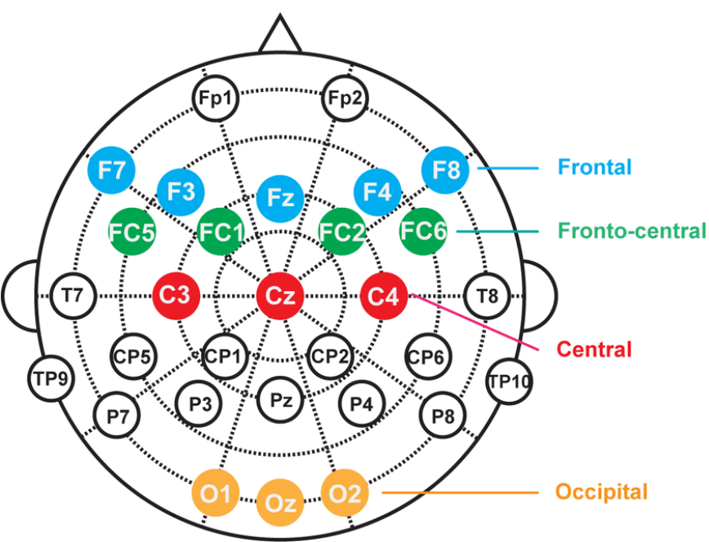

Fig. 2. Placement of EEG electrodes in International 10‐5 system (for Dataset I).

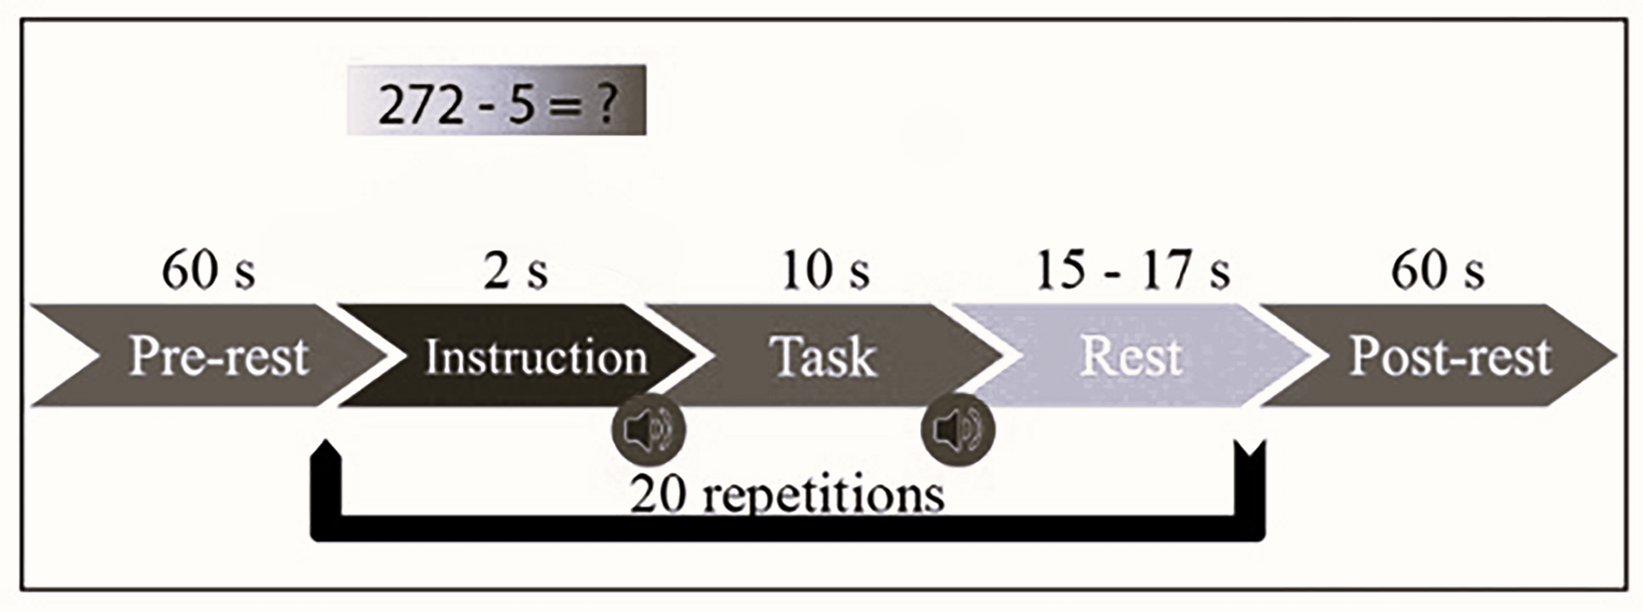

Fig. 3. Schematic sequence diagram of the experimental setup consisted of a 1minute pre task rest, followed by 20 task repetitions, and concluded with a 1minute post task rest. Each task cycle began with a 2 second visual task introduction, succeeded by a 10 second task period, and randomly timed resting periods lasting between 15 to 17 seconds. Short 250ms beeps marked both the start and end of each task period (for Dataset I).

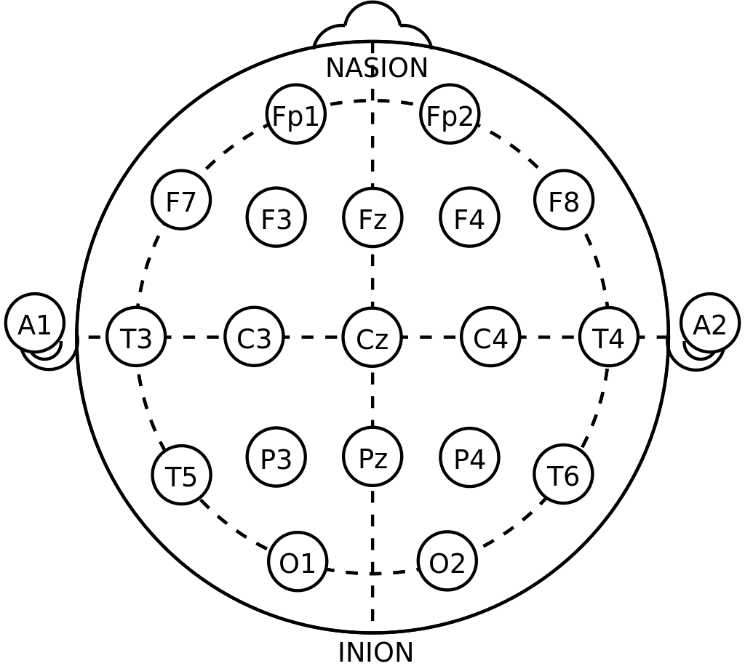

Fig. 4. Placement of EEG electrodes in International 10‐20 system (for Dataset II)

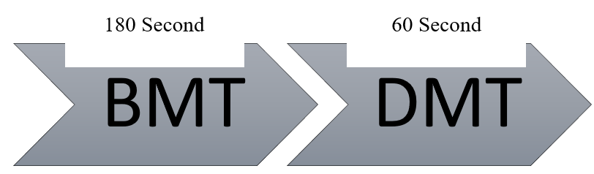

Fig. 5. Sequence diagram for collecting EEG Data in 21-Channel EEG. There will be first 180 second for Before mental task (BMT) And 60 second for During mental task (DMT) (Dataset II)

In our study, we utilized two distinct datasets, namely Dataset I and Dataset II, to investigate brain activity patterns during mental arithmetic tasks and baseline conditions.  
In Dataset I, EEG data were collected from 29 subjects, focusing on mental arithmetic (MA) [18] tasks and baseline (BL) [19] conditions. The dataset consists of 32-channel  
‘Fig. 2” EEG recordings, with each subject contributing data for both MA and BL conditions. The sampling frequency for Dataset I was set at 200 Hz.

For Dataset II, EEG data were collected from 35 subjects, with recordings taken both before (BMT) and during (DMT) [20] the performance of mental [18] arithmetic tasks. The dataset II comprises 21 channel EEG recordings, divided into two folders: BMT and DMT. The sampling frequency for Dataset II was set at 500 Hz.

**2.3 Data preprocessing**

The collected datasets from open sources underwent comprehensive preprocessing to mitigate the impact of noise and artifacts inherent in EEG signals. Due to the susceptibility of EEG signals to various artifacts during data collection, steps such as filtering, dereferencing, epoch segmentation, and artifact removal were employed to enhance signal fidelity.

To address residual artifacts, all recordings underwent additional digital filtering using a band-pass filter. This filter had cutoff frequencies set at 0.2 Hz and 40 Hz, effectively attenuating noise outside this frequency range. By implementing these pre-processing techniques, the datasets were refined to ensure that EEG signals accurately reflected brain activity, facilitating more reliable analysis and interpretation in subsequent research endeavors.

**2.4 Feature Extraction**

When we study how our brain handles different tasks, we look at various aspects of cognitive load [21]. Time domain features show us how brain activity changes over time [9] [10], giving us insight into how our thinking evolves. Frequency domain features tell us about the energy in different brain wave frequencies [22], showing which frequencies are important for cognitive load. Time-frequency features combine time and frequency data [23], letting us see how cognitive demands change over time. Spatial features reveal where in the brain activity is happening [24]. Nonlinear dynamics features uncover complex patterns in brain signals [25]. Lastly, connectivity network features show how different brain regions communicate. While time and frequency domain features “Table. I” are often considered most important, our study focuses on exploring them further to better understand cognitive load.

Time domain features are crucial in cognitive load analysis as they provide insights into the temporal dynamics of cognitive processes. By examining signal characteristics over time, such feature given in “Table. I” , time domain features reveal how cognitive load evolves during tasks. They help track changes in mental effort and attention, aiding in the understanding of cognitive workload fluctuations. Therefore, time domain features play a pivotal role in capturing the dynamic nature of cognitive demands during various cognitive tasks.

TABLE I

TIME AND FREQUENCY DOMAIN FEATURES

|  |  |
| --- | --- |
| Time Domain | Frequency Domain |
| Mean | Mean |
| Median | Median |
| Variance | Variance |
| Skewness | Standard Deviation |
| Kurtosis | Skewness |
| Minimum | Kurtosis |
| Maximum | Band Power Alpha |
| Hjorth Mobility | Band Power Beta |
| Hjorth Complexity | Band Power Delta |
| Hjort Activity | Band Power theta |
| Mean Energy | Ratio Band Power Alpha Beta |
| Standard deviation | Ratio Band Power Beta Gamma |
| First Difference | Ratio Band Power Alpha Gamma |

In our research methodology, we meticulously crafted a strategy for extracting feature matrices from EEG data, critical for unraveling cognitive processes across different sessions. Employing a window-based system allowed for precise feature extraction, with each window spanning 600 samples and a 66% overlap between consecutive windows, thereby ensuring the reliability of our findings. Within each window, time domain features were meticulously computed for each EEG channel, resulting in a feature matrix dimension of 1 × (32 * 12). To distinguish between sessions, we allocated a label of 1 to data from the Before Mental Task [20] (BMT) session and a label of 0 to data from the During Mental Task [20] (DMT) session, thus expanding the dimension of each window to 1× (32 * 12 + 1), incorporating the session label.

Considering the variability in window size denoted by ’n’ across subjects, the overall dimension of the feature matrix for all DMT sessions reached (29 * n) x (32 * 12 + 1). However, factoring in the presence of BMT data, featuring 8 sessions per subject, the dimension significantly expanded to (8 * 29) x (32 * 12 + 1). Consequently, the comprehensive feature matrix encompassing both DMT and BMT sessions attained a dimension of (29 * (8 + n)) x (32 * 12 + 1). This meticulously structured feature matrix stands as the bedrock of our research, offering a robust dataset for thorough analysis and exploration of cognitive load dynamics during various mental tasks.

Through rigorous investigation and interpretation of this feature-rich dataset, we aim to deepen our understanding of cognitive processes and contribute meaningfully to the advancement of cognitive neuroscience research. By leveraging this meticulously constructed dataset, we endeavor to uncover nuanced insights into cognitive load dynamics and pave the way for novel discoveries in the field of cognitive neuroscience.

**2.5 Normalization of feature matrix**

Normalization is a crucial data preprocessing technique used to standardize feature scales within a dataset [26], ensuring uniformity and comparability. In our study, MinMax normalization was applied to the entire feature matrix, scaling each feature’s values to a range of 0 to 1. This mitigated the impact of varying scales among different features, preventing larger-scale features from dominating smaller ones during analysis. Following normalization, categorical class labels were assigned, with ’0’ representing instances of Before Mental Task (BMT) and ’1’ representing instances of During Mental Task (DMT). These labels were appended to the feature matrix, facilitating the distinction between the two mental task categories and laying the groundwork for further analysis. Overall, normalization enhances the interpretability of results, stabilizes machine learning algorithms, and ensures fair comparisons between features.

**2.6 Feature Selection**

Feature selection and ranking are pivotal in research, serving to identify influential variables within a dataset and streamline analyses by prioritizing key contributors. Through techniques such as filter, wrapper, and embedded methods, researchers can discern the most informative features for classification tasks. In our study, we employed chi-square tests, the ReliefF algorithm, and the Minimum Redundancy Maximum Relevance (MRMR) Algorithm with k=50, to perform feature selection and ranking.

The ReliefF algorithm evaluates feature importance by assessing their discriminatory power in distinguishing instances within the feature space. It excels in handling imbalanced datasets, robustly dealing with noisy and redundant features. Similarly, the MRMR Algorithm prioritizes features that maximize relevance to the target variable while minimizing redundancy among selected features. By considering the interplay between relevance and redundancy, MRMR facilitates the identification of a compact and informative feature subset.

Additionally, chi-square tests quantify the independence between features and the target variable, providing insights into the significance of associations. These techniques yield feature rankings, guiding the selection of the most informative variables for classification.

To visually depict the significance of ranked features, we present a “Feature vs. Importance” graph (refer to Figure 4). Moreover, a table showcasing the top 5 features selected from each algorithm (see Table II) is provided, underscoring their importance in classification tasks. The selection of these top features is based on their high discriminatory power, relevance to the target variable, and minimal redundancy, ensuring the inclusion of the most informative variables for optimal model performance and meaningful insights from the data. Additionally, for feature selection, we prioritize the identification of the top 50 most impactful features. However, due to space constraints, we present a condensed summary by showcasing the five most valuable features in a tabulated format.

TABLE II

TOP 5 FEATURES SELECTED FROM EACH ALGORITHM FOR DATASET I & II

|  |  |  |  |  |  |  |
| --- | --- | --- | --- | --- | --- | --- |
| Dataset I | chi-square test | | ReliefF algorithm | | MRMR Algorithm | |
| Channel | Feature | Channel | Feature | Channel | Feature |
| F3 | Mean | P7 | Kurtosis | AFp1 | Min |
| F4 | Mean | P7 | Variance | F7 | Max |
| P8 | Variance | P7 | Hjorth Activity | PPO2h | Max |
| P3 | SD | POO1 | Kurtosis | F4 | Max |
| Cz | Skewness | HEOG | Hjorth Activity | CCP4h | Min |
| Dataset II | C3 | Mean | F3 | SD | Cz | Max |
| T5 | SD | F7 | Variance | Fp1 | Min |
| FP2 | Kurtosis | P4 | Hjorth Activity | T4 | Min |
| C3 | Mean | Fz | Kurtosis | F8 | Max |
| P3 | Variance | T3 | Mean | Pz | Min |

**CHAPTER 3: CLASSIFICATION**

The selection of classifiers for comparative analysis in cognitive load classification is rooted in the distinctive advantages conferred by each algorithm, meticulously tailored to the EEG data characteristics and the intricate demands of the classification task. Linear Discriminant Analysis (LDA) is chosen for its capacity to optimize class separability by projecting data into a lower-dimensional space, ideal for EEG features with potentially linear relationships. Support Vector Machine (SVM) with a Linear kernel is adept at navigating high-dimensional feature spaces, establishing resilient decision boundaries, and effectively managing complex data relationships. Additionally, K-Nearest Neighbors (KNN) is integrated for its simplicity and efficacy in classifying data points based on their proximity within the feature space.

This comprehensive approach amalgamates diverse classifiers, including Neural Network (NN), to provide a nuanced evaluation framework for identifying the most effective model in cognitive load classification “Table. III”. The inclusion of a diverse array of classifiers enriches the analysis, ensuring thorough exploration of various modeling strategies and bolstering the reliability and generalizability of the results.

During the training phase, each classifier is meticulously trained using labeled data derived from the feature matrix. A rigorous partitioning strategy allocates 80% of the data for training purposes, with the remaining 20% reserved for testing. The feature matrix is systematically introduced to each classifier during training, incrementally incorporating predictors from one to all, to discern the incremental impact of additional features on model accuracy. Rigorous cross validation, employing 10 folds, is applied to each iteration, ensuring robust performance assessment. The ensuing accuracy curves, delineating the relationship between accuracy and feature number, serve as invaluable tools for discerning the optimal feature subset for each classifier.

**3.1 Linear Discriminant Analysis (LDA) Classifier**

The LDA classifier demonstrates a moderate level of performance in cognitive load classification. While achieving an accuracy of 62.99% indicates the model’s ability to correctly classify instances, the precision and recall scores of 61.65% and 62.99%, respectively, suggest a balanced performance in identifying true positives and minimizing false positives. However, the F1 score of 59.79% reflects the harmonic mean of precision and recall, indicating room for improvement in overall model accuracy. The confusion matrix provides further insight, revealing 186 true negatives and 781 true positives, but also highlighting 430 false positives and 138 false negatives. This suggests areas for model refinement, particularly in reducing false positives and false negatives to enhance classification accuracy and reliability.

**3.2 Support Vector Machine (SVM) Classifier**

The SVM model yielded an accuracy of 60.59%, indicating its ability to correctly classify instances. However, the precision and recall scores varied significantly between the two classes. While achieving a precision of 79% for class 0 suggests the model’s capability to correctly identify true negatives, the recall for the same class was only 2%, indicating a high rate of false negatives. Conversely, class 1 exhibited a precision of 60% and a recall of 100%, indicating the model’s effectiveness in correctly identifying true positives while minimizing false negatives.

The F1-score, which considers both precision and recall, was notably higher for class 1 (0.75) compared to class 0 (0.05), reflecting the imbalance in performance between the two classes. The confusion matrix further elucidates these findings, revealing 15 true negatives, 601 false positives, 4 false negatives, and 915 true positives. This suggests potential areas for model refinement, particularly in improving the classification of class 0 instances to enhance overall model accuracy and reliability

**3.3 K-Nearest Neighbors (KNN) Classifier**

The KNN model achieved an accuracy of 75.64%, indicating its ability to correctly classify instances. The precision and recall scores varied slightly between the two classes, with class 1 exhibiting higher values. For class 0, the precision was 74% and the recall was 60%, suggesting a moderate ability to identify true negatives while missing some instances. Conversely, for class 1, the precision was 76% and the recall was 86%, indicating the model’s effectiveness in correctly identifying true positives while minimizing false negatives. The F1-score, which considers both precision and recall, was higher for class 1 (0.81) compared to class 0 (0.67), reflecting the imbalance in performance between the two classes. The confusion matrix further illustrates these findings, with 372 true negatives, 244 false positives, 130 false negatives, and 789 true positives. Overall, the KNN model demonstrates robust performance, particularly in accurately classifying instances of class 1, but may benefit from further refinement to improve classification of class 0 instances and enhance overall model accuracy.

**4.4 Neural Network (NN) Classifier**

The Neural Network (NN) model achieved an accuracy of 65.34%, indicating its ability to correctly classify instances. The precision and recall scores varied notably between the two classes, with class 1 exhibiting higher values. For class 0, the precision was 64% and the recall was 30%, indicating a moderate ability to identify true negatives while missing a significant number of instances. Conversely, for class 1, the precision was 66% and the recall was 89%, suggesting the model’s effectiveness in correctly identifying true positives while minimizing false negatives. The F1-score, which considers both precision and recall, was notably higher for class 1 (0.75) compared to class 0 (0.41), reflecting the imbalance in performance between the two classes. The confusion matrix further illustrates these findings, with 187 true negatives, 429 false positives, 103 false negatives, and 816 true positives. Overall, the NN model demonstrates moderate performance, particularly in accurately classifying instances of class 1, but may benefit from further refinement to improve classification of class 0 instances and enhance overall model accuracy.

**CHAPTER 4: Results**

In our study, we endeavored to devise a robust classifier model for discerning the mental state of individuals engaged in cognitive tasks, utilizing EEG data. We conducted a comprehensive evaluation of four machine learning algorithms: Linear Discriminant Analysis (LDA), Support Vector Machine (SVM), K-Nearest Neighbors (KNN), and Neural Network (NN). Each model was trained to classify EEG signals into two categories: Before Mental Task (BMT) and During Mental Task (DMT).

The results revealed notable variations in model performance. LDA exhibited a commendable accuracy of 75%, with a precision of 0.74 and a recall of 0.60. SVM, though achieving a lower accuracy of 61%, demonstrated a high precision of 0.79. KNN presented an accuracy of 65% “Table. III” with a balanced precision-recall trade-off, while NN showcased comparable performance to KNN

TABLE III

SUMMARY OF CLASSIFIER PERFORMANCE FOR DATASET I & II

|  |  |  |  |  |  |
| --- | --- | --- | --- | --- | --- |
| Dataset I | Classifier | Accuracy | Precision | Recall | F1-Score |
| LDA | 0.75 | 0.74 | 0.60 | 0.67 |
| SVM | 0.61 | 0.79 | 0.25 | 0.50 |
| KNN | 0.65 | 0.64 | 0.30 | 0.41 |
| NN | 0.65 | 0.66 | 0.89 | 0.75 |
| Dataset II | LDA | 0.84 | 0.83 | 0.84 | 0.33 |
| SVM | 0.82 | 0.83 | 0.96 | 0.89 |
| KNN | 0.79 | 0.79 | 0.53 | 0.85 |
| NN | 0.94 | 0.96 | 0.96 | 0.88 |

The performance of the classifiers, namely Linear Discriminant Analysis (LDA), Support Vector Machine (SVM), K-Nearest Neighbors (KNN), and Neural Network (NN), was evaluated using labeled feature matrices from Dataset II. Across all models “Table. III”, LDA demonstrated the highest accuracy, precision, recall, and F1-Score, with an accuracy of 84.19%. SVM followed closely behind with an accuracy of 82.43%, exhibiting a balance between precision and recall. KNN, while achieving a lower accuracy of 75.91%, displayed a notable imbalance between precision and recall, particularly for the minority class. The NN model, implemented using a KNN classifier, yielded comparable results to KNN in terms of accuracy and precision-recall balance.

Overall, LDA emerges as the most suitable classifier for the cognitive load classification task on both Datasets, given its superior performance metrics. However, the choice of classifier should be contingent on the specific requirements of the application. SVM may be preferred for scenarios prioritizing a balance between precision and recall, while KNN and NN could be viable alternatives for their simplicity and computational efficiency. These results underscore the importance of selecting an appropriate classifier based on the task objectives and data characteristics to achieve optimal performance in cognitive load classification.

Despite the inherent challenges of EEG data analysis, our models demonstrated varying degrees of accuracy, precision, recall, and F1-Score. Overall, the results underscore the feasibility of using machine learning approaches for cognitive load classification, with potential implications for real-time monitoring of mental states in various applications, including education, healthcare, and human-computer interaction. These findings hold promise for advancing our understanding of cognitive processes and enhancing the development of personalized interventions and adaptive systems.

**CHAPTER 5: Conclusion**

Our study elucidates the efficacy of machine learning algorithms, particularly emphasizing the superiority of Linear Discriminant Analysis (LDA), in EEG-based cognitive load classification. Through meticulous analysis, we have successfully differentiated between task and rest mental states, a crucial aspect in cognitive load assessment. Notably, LDA's consistent outperformance of alternative classifiers across diverse datasets underscores its robustness and reliability in real-time cognitive load monitoring scenarios. The precision and accuracy exhibited by LDA highlight its potential in various applications necessitating cognitive state discrimination, such as driver fatigue detection, mental workload assessment in pilots, and educational technology for personalized learning experiences. This emphasizes LDA's role as a pivotal tool in enhancing human-computer interaction and optimizing performance across a spectrum of cognitive tasks and environments.

Moving forward, there's an opportunity to enhance feature selection techniques and explore ensemble learning methods to further boost classification accuracy. Additionally, integrating multimodal data fusion and real-time feedback mechanisms could augment the utility of cognitive load classification systems. However, it's essential to acknowledge certain limitations, such as dataset variability and potential model overfitting, which warrant cautious interpretation of results. Addressing these limitations through rigorous validation and broader dataset inclusion could strengthen the reliability and generalizability of future findings.

**Bibliography**

[1] L. F. Nicolas-Alonso and J. Gomez-Gil, “Brain computer interfaces, a review,” sensors, vol. 12, no. 2, pp. 1211–1279, 2012.

[2] A. Dan, M. Reiner et al., “Real time eeg based measurements of cognitive load indicates mental states during learning,” Journal of Educational Data Mining, vol. 9, no. 2, pp. 31–44, 2017.

[3] R. Foong, K. K. Ang, C. Quek, C. Guan, K. S. Phua, C. W. K. Kuah, V. A. Deshmukh, L. H. L. Yam, D. K. Rajeswaran, N. Tang et al., “Assessment of the efficacy of eeg-based mi-bci with visual feedback and eeg correlates of mental fatigue for upper-limb stroke rehabilitation,” IEEE Transactions on Biomedical Engineering, vol. 67, no. 3, pp. 786– 795, 2019.

[4] G. Valente, A. L. Kaas, E. Formisano, and R. Goebel, “Optimizing fmri experimental design for mvpa-based bci control: Combining the strengths of block and event-related designs,” NeuroImage, vol. 186, pp. 369–381, 2019. [Online]. Available: https://www.sciencedirect.com/ science/article/pii/S1053811918320615

[5] S. Roy, D. Rathee, K. McCreadie, and G. Prasad, “Channel selection improves meg-based brain-computer interface,” in 2019 9th International IEEE/EMBS Conference on Neural Engineering (NER). IEEE, 2019, pp. 295–298.

[6] C. Li, M. Su, J. Xu, H. Jin, and L. Sun, “A between-subject fnirsbci study on detecting self-regulated intention during walking,” IEEE transactions on neural systems and rehabilitation engineering, vol. 28, no. 2, pp. 531–540, 2020.

[7] A. S. Al-Fahoum and A. A. Al-Fraihat, “Methods of eeg signal features extraction using linear analysis in frequency and time-frequency domains,” International Scholarly Research Notices, vol. 2014, 2014.

[8] C. Vidaurre, N. Kramer, B. Blankertz, and A. Schl ¨ ogl, “Time domain ¨ parameters as a feature for eeg-based brain–computer interfaces,” Neural Networks, vol. 22, no. 9, pp. 1313–1319, 2009.

[9] P. Geethanjali, Y. K. Mohan, and J. Sen, “Time domain feature extraction and classification of eeg data for brain computer interface,” in 2012 9th international conference on fuzzy systems and knowledge discovery. IEEE, 2012, pp. 1136–1139.

[10] M. Diykh, Y. Li, and P. Wen, “Eeg sleep stages classification based on time domain features and structural graph similarity,” IEEE Transactions on Neural Systems and Rehabilitation Engineering, vol. 24, no. 11, pp. 1159–1168, 2016.

[11] P. Bashivan, I. Rish, and S. Heisig, “Mental state recognition via wearable eeg,” arXiv preprint arXiv:1602.00985, 2016.

[12] T. Lan, A. Adami, D. Erdogmus, and M. Pavel, “Estimating cognitive state using eeg signals,” in 2005 13th European Signal Processing Conference. IEEE, 2005, pp. 1–4.

[13] J. Sweller and P. Chandler, “Evidence for cognitive load theory,” Cognition and instruction, vol. 8, no. 4, pp. 351–362, 1991.

[14] H. Lee, J. L. Plass, and B. D. Homer, “Optimizing cognitive load for learning from computer-based science simulations.” Journal of educational psychology, vol. 98, no. 4, p. 902, 2006.

[15] U. Tugtekin and H. F. Odabasi, “Do interactive learning environments have an effect on learning outcomes, cognitive load and metacognitive judgments?” Education and Information Technologies, vol. 27, no. 5, pp. 7019–7058, 2022.

[16] A. Shaban, E. Pearson, and V. Chang, “Evaluation of user experience, cognitive load, and training performance of a gamified cognitive training application for children with learning disabilities,” Frontiers in Computer Science, vol. 3, p. 617056, 2021.

[17] A. Qayyum, M. A. Khan, M. Mazher, and M. Suresh, “Classification of eeg learning and resting states using 1d-convolutional neural network for cognitive load assesment,” in 2018 IEEE Student Conference on Research and Development (SCOReD). IEEE, 2018, pp. 1–5.

[18] A. Maghsoudi and A. Shalbaf, “Mental arithmetic task recognition using effective connectivity and hierarchical feature selection from eeg signals,” Basic and Clinical Neuroscience, vol. 12, no. 6, p. 817, 2021.

[19] S.-I. Choi, G.-Y. Choi, H.-T. Lee, H.-J. Hwang, and J. Shin, “Classification of mental arithmetic and resting-state based on ear-eeg,” in 2018 6th International Conference on Brain-Computer Interface (BCI). IEEE, 2018, pp. 1–4.

[20] T. Fernandez, T. Harmony, M. Rodr ´ ´ıguez, J. Bernal, J. Silva, A. Reyes, and E. Marosi, “Eeg activation patterns during the performance of tasks involving different components of mental calculation,” Electroencephalography and clinical neurophysiology, vol. 94, no. 3, pp. 175–182, 1995.

[21] S. Kalyuga, “Cognitive load theory: How many types of load does it really need?” Educational psychology review, vol. 23, pp. 1–19, 2011.

[22] M. Mazher, A. Abd Aziz, A. S. Malik, and H. U. Amin, “An eegbased cognitive load assessment in multimedia learning using feature extraction and partial directed coherence,” IEEE Access, vol. 5, pp. 14 819–14 829, 2017.

[23] J. Yedukondalu, D. Sharma, and L. D. Sharma, “Subject-wise cognitive load detection using time–frequency eeg and bi-lstm,” Arabian Journal for Science and Engineering, pp. 1–13, 2023. [24] K. A. Longstaffe, B. M. Hood, and I. D. Gilchrist, “The influence of cognitive load on spatial search performance,” Attention, Perception, & Psychophysics, vol. 76, pp. 49–63, 2014.

[25] R. Lamb, A. Cavagnetto, and T. Akmal, “Examination of the nonlinear dynamic systems associated with science student cognition while engaging in science information processing,” International Journal of Science and Mathematics Education, vol. 14, pp. 187–205, 2016.

[26] M. Gheorghe and R. Petre, “The importance of normalization method for mining medical data,” J. Int. J. Computers Technol, vol. 14, pp. 6014–6020, 2015